**BigData Case study**

**E Commerce – BigData**

MyCart is an E-Commerce site that sells products. Customer place orders and pay the money

through e Payment mode. They have huge database gathered over years and the management wants

to use the data for better analysis and improvement of business. As the investments are going high,

they want to use a cheaper solution that can be used for better analytics.

They have decided to setup a Hadoop cluster and use Hive as their database for storing data. They

must develop a data model from the existing data model and then transfer the entire data from their

traditional database system (ex. MySQL) to Hive. Consider the table structures given below.

* **Create MySQL tables and insert dummy data into it according to the problem statement**.

1. Sqoop incremental import needs to implemented to import the data from MySQL table(created earlier) into HDFS incrementally.

Creating table inventory_item

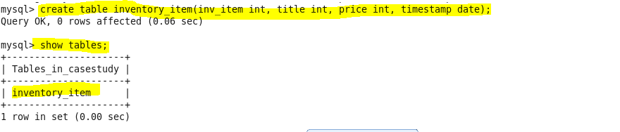

Inserting data into the table

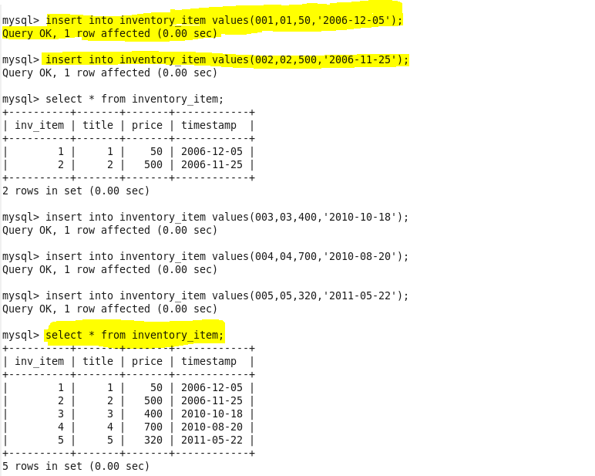

Adding primary key to the table

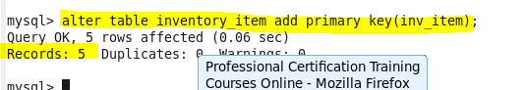

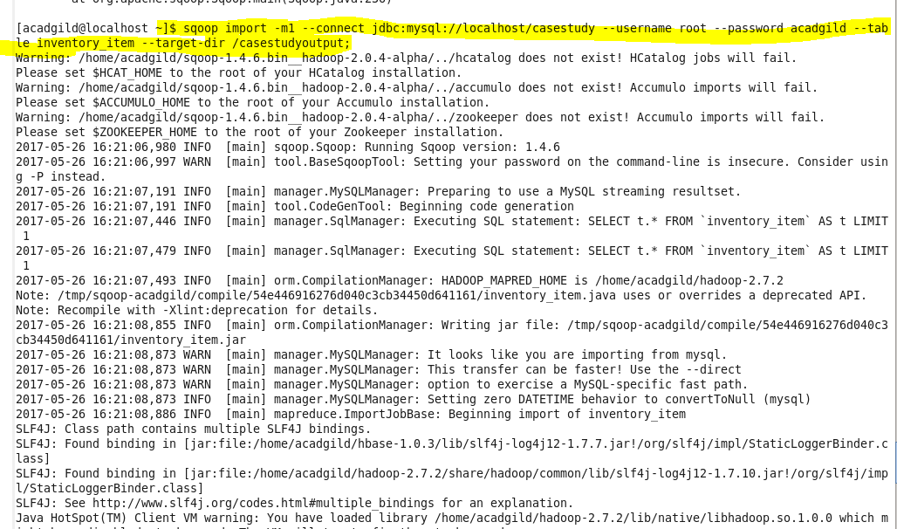

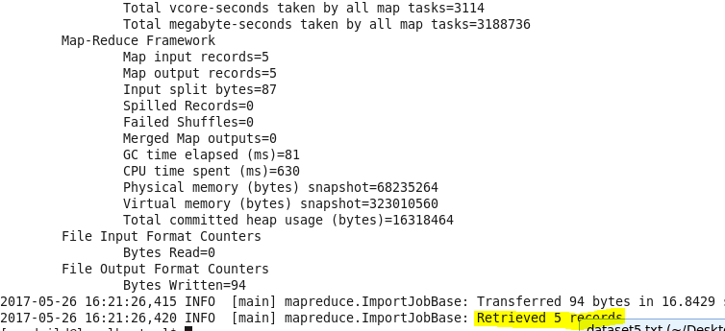

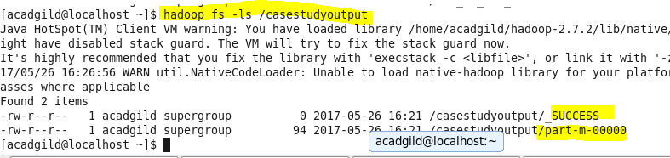

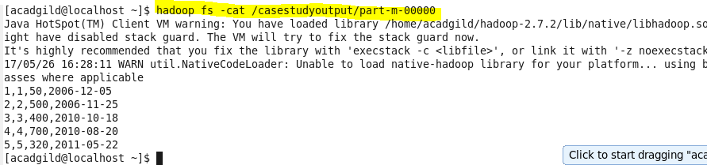

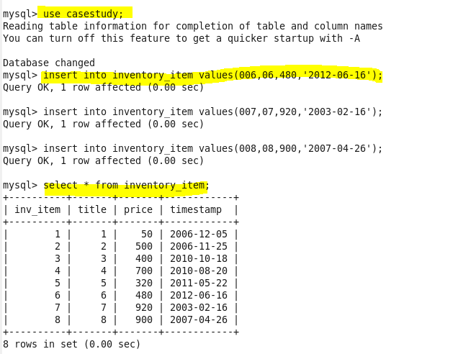

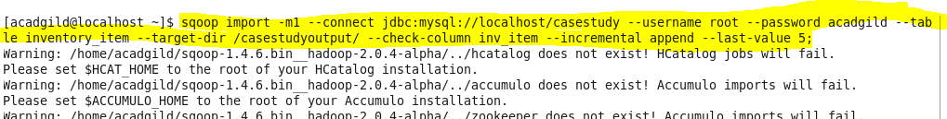

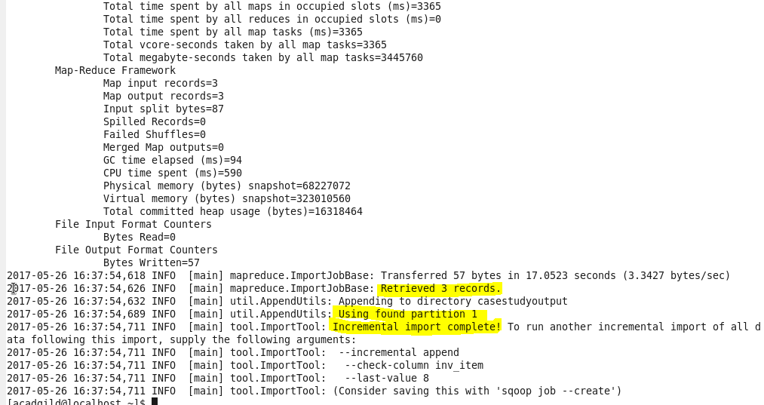

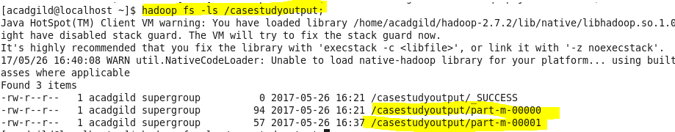

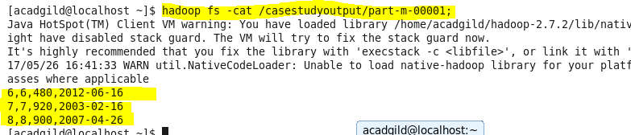

Query 2

